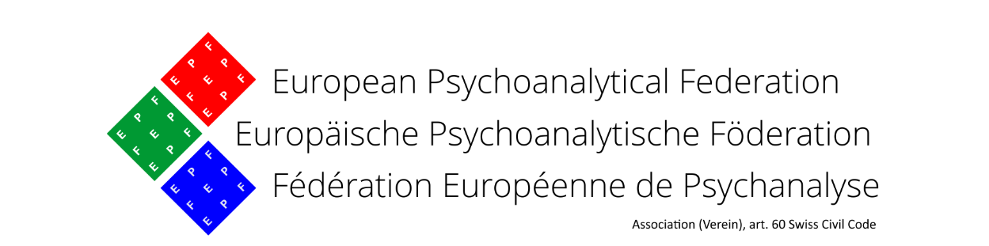

**8th European Psychoanalytic Conference for University Students - EPCUS**

**E.P.F. House, Rue Gérard 35, B-1040 Brussels, Belgium**

**October 5 – October 7, 2023**

**REGISTRATION FORM**

|  |  |
| --- | --- |
| Date: |  |
| Name of participant: |  |
| First name: |  |
| Full postal address: |  |
| Email: |  |
| Student: | Yes  No |
| University: |  |
| Country: |  |
| Field of studies: |  |
| Fee: 30€ |  |
| I am willing to participate: | In-person in the EPF House in Brussels  Online |
| For in person attendants:  please state your dietary preferences |  |

**Accommodation** in hostels available:

<https://www.visit.brussels/en/visitors/where-to-stay/all-accommodations>

<https://bnb.brussels/en/>

**Please, note that each participant has to book his hostel room!!!**

Please transfer the registration fee in **Euros** to:

**Bank JULIUS BÄR, ZURICH, Switzerland**

**IBAN: CH79 0851 5030 9973 4200 4  
SWIFT: BAERCHZZ**

**Name: European Psychoanalytical Federation**

**Communication: EPCUS 2023 + Name of the participant**

Please, fill in and send this registration form as soon as possible via email, but please  
**no later than September 18th,** to: Frank Goderniaux (frank.goderniaux@epf-fep.eu) and Mercedes Puchol ([mpuchol@futurnet.es](mailto:mpuchol@futurnet.es))

In due course, after the registration and the payment, you will receive information about your participation status (in-person or online) and all additional data for your convenient participation.